Ezkylle Opiniano 11/25/2025
NW – 301 6BLOCKTECH
Constants.sol
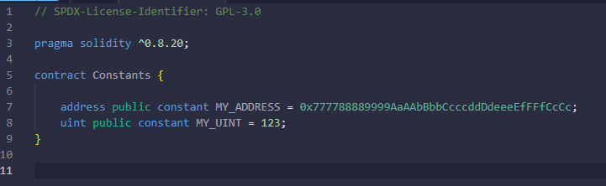
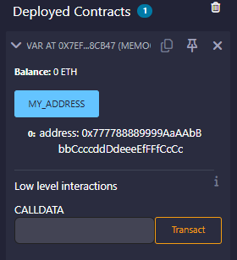

Mapping.sol
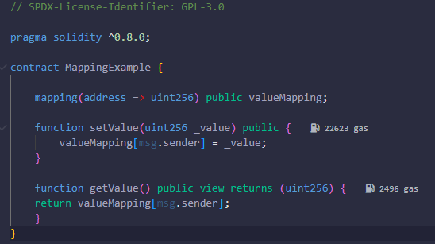
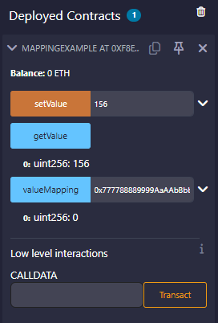

ErrorHandling.sol
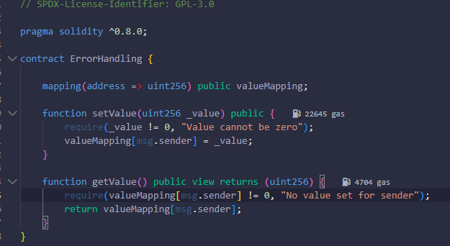
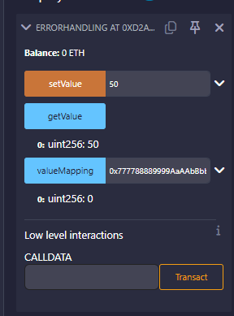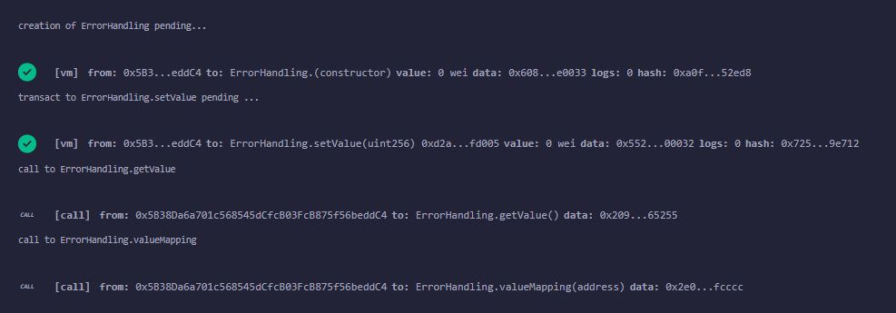
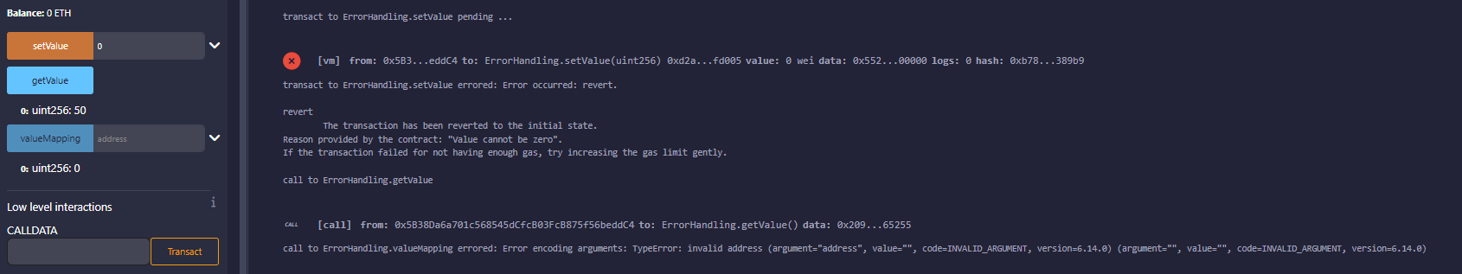

FunctionModifier.sol
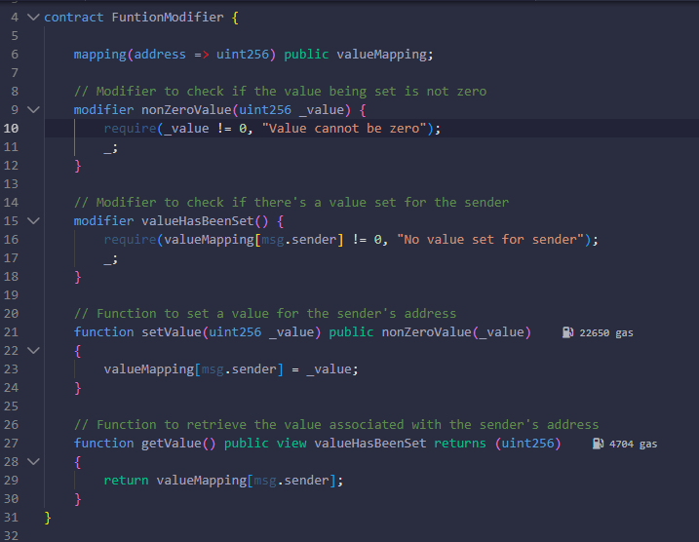
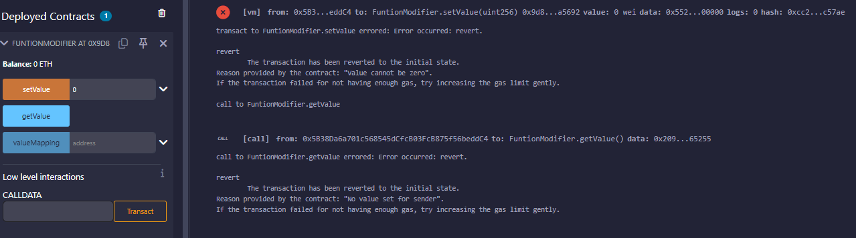
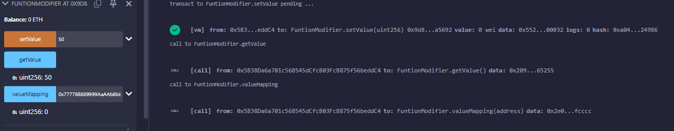
Ownable.sol
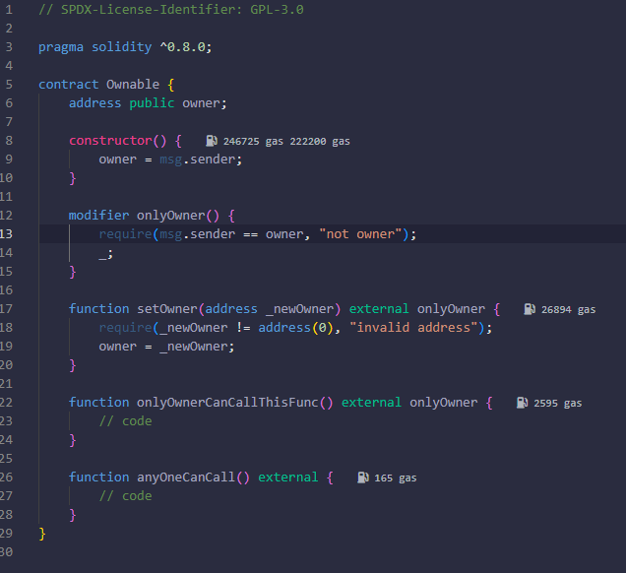
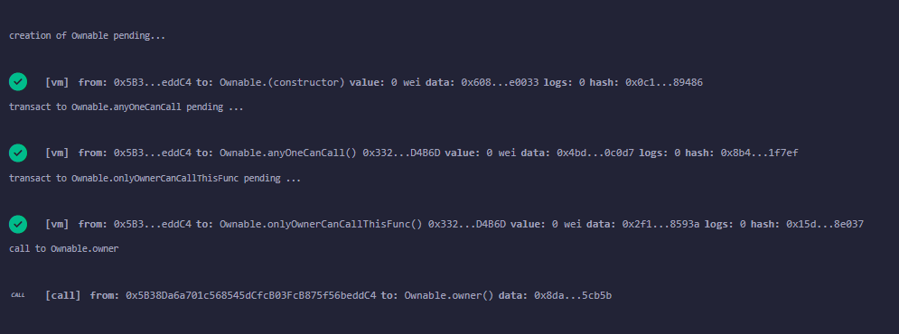
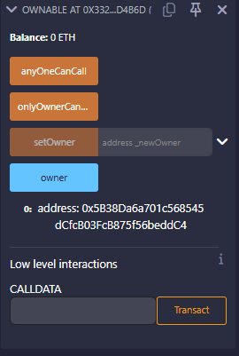

Reflection Question
- Function Modifiers & Ownable
When should you use a modifier like onlyOwner instead of inline checks, and what risks arise if ownership isn’t managed properly?
  - When the same access-control rule occurs in several functions, use modifiers like onlyOwner, as they maintain cleaner, consistent, and less misused code than repeated inline checks. Inline checks are acceptable for one-time conditions, but modifiers eliminate redundancies and the risk of making mistakes. Inefficient management of ownership can lead to unauthorized access, which in turn would result in locking of critical functionality if ownership is lost, or even the centralization of too much power in a single key that can be compromised, thus making the contract insecure or unusable.

- Error Handling
How do you choose between require, revert, and assert, and why might custom errors be better than error strings?
  - Require should be used for checking inputs or external conditions, while revert is best for signaling failure at deep logic or when custom errors are employed, and assert is to be used only for invariants that should always hold unless bug exists. Custom errors are much preferred over string messages because they are very cheap in gas, give structured data, and do not lead to large revert strings that increase both contract size and execution cost.

- Constants & Variables
When should a value be constant, immutable, or mutable, and how does that choice affect gas cost and flexibility?
  - Use constant for values known at compile time, immutable for values known only at deployment but never changed afterward, and mutable variables for values that must be updated during the contract’s lifetime. Constants and immutables are much cheaper to read because they are stored in bytecode rather than storage, lowering gas costs. On the other hand, mutable variables are more flexible but at the same time require expensive storage operations.

